**Project 1**

**<Chō-han dice game>**

**Cis-5-49006**

**Name: Mason Cotterill**

**Date: 11/4/2017**

**Introduction**

Title: Chō-han dice game

This is the Chō-han dice game.

The game asks how many players you want to play between 2 and 9.

Then it asks if the user would like to bet on odd or even or whether or not the user wants to pass.

It randomly selects numbers and depending on what user picked it you win or lose money.

Program asks user if they would like to bet again on even or odd and selects random dice rolls and depending on winnings it continues but if no money is left program ends.

Chō-han is commonly used to bet on in the streets of Japan.

**Summary**

Project size: About 180 lines

Number of variables: About 21

The number of method: 4

This project includes many concepts that we learned from the chapters in the book Also, it has many possibilities to be extended for next project.

For example more players and more rounds could be added to make it more complex.

It took several weeks because I tried to do several different games but couldn’t figure them out. I had many problems and left many of them for next project. I’m not satisfied with this project, but it was a good learning experience. I realized that C++ has numerous functions that I didn’t know about. Although this is a very simple betting game, I think I tried to use as many of the concepts we learned in the previous weeks.

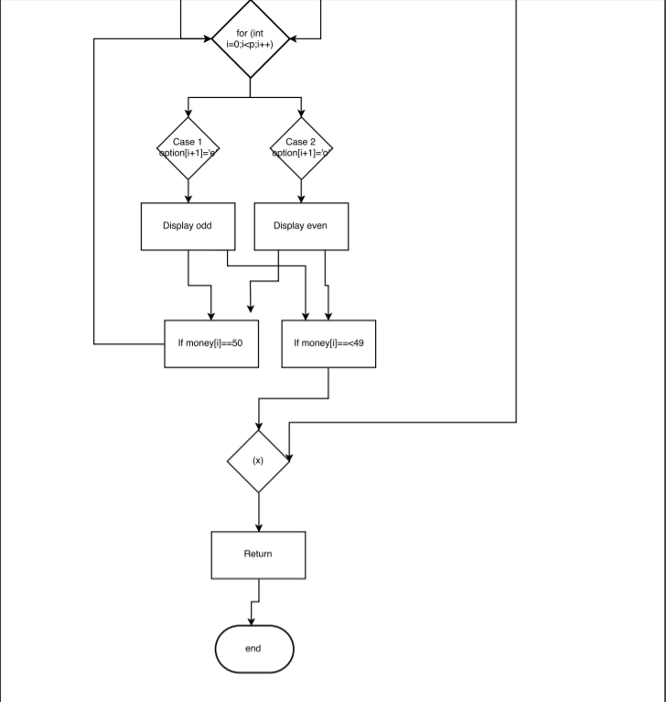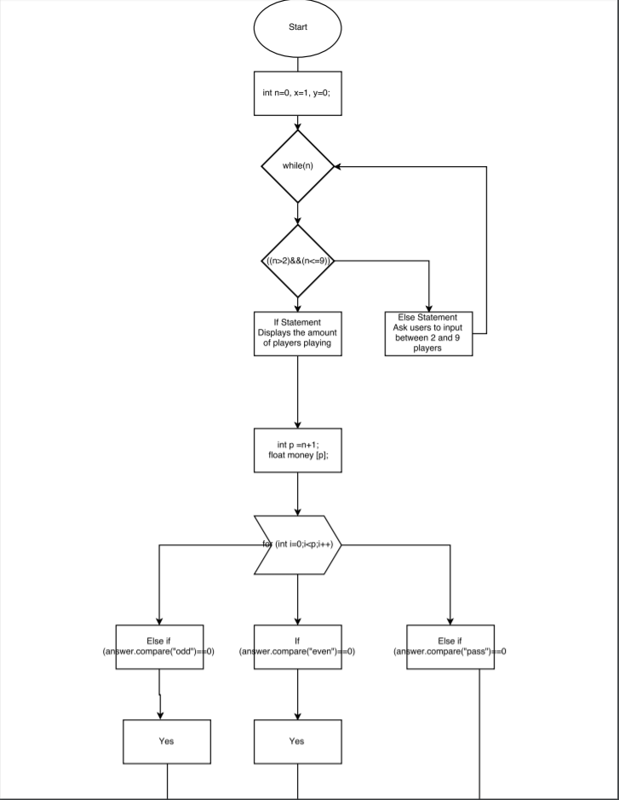



**Pseudo Code**

*Initialize*

*If the program is ran*

*Ask user for the amount of players*

*If between 2-9 continue*

*Else Prompt user for number between 2 and 9*

*Do ask user for an odd or even bet*

*If even select e*

*Else if odd select o*

*Else if pass select p*

*For Option of Even or Odd*

*Switch Case 1 and 2*

*Case 1 Odd plus 1*

*Case 2 Even plus 1*

*If bet was lost subtract $50*

*Else user passed ending the game*

*If user decided to continue*

*Switch Case Even and Odd*

*Case Even If roll dice =1, Else roll dice=0*

*Case Odd If roll dice =1, Else roll dice=0*

*Switch Case Even and Odd*

*Case Even If roll dice =1, Else roll dice=0*

*Case Odd If roll dice =1, Else roll dice=0*

*If money is above $50 then run again*

*Display all players money*

*Else money is under $50 then game ends*

**Program**

#include <iostream> //library for standard input/output streams

#include <stdlib.h> //standard library that includes functions involving memory allocation, process control, conversions

#include <time.h> //standard library for use of time/date manipulation

using namespace std;

//Program Execution Begins Here

int main(int argc, char** argv) {

//Declare all Variables Here

int n=0, x=1, y=0;

cout<<"How many players are playing?\nPlease enter between 2 and 9 players:\n";

cin>>n; //User input between 2 and 9 players

while(n)

{

if ((n>=2) && (n<=9)) //If statement that displays numbers between 2 and 9

{

cout<<"There are " << n << " players playing.\n";

break;

}

else

{

cout<<"Please enter a number between 2-9.\n";

cin>>n;

}

}

//Input or initialize values Here

int p = n+1; //setting p=n+1

float money[p]; //using float to two decimal places

for (int i=0;i<p;i++)

{

money[i] = 500.00; //sets all the players money to 100.00

}

char option[p]; //this allows for the player to pick an option

int win[p]; //the amount of money players will win

int pass=0; //the use of the pass function

string answer; //this is the user inputed answer

do

{

cout<<"Would you like to bet on odd or even?\nIf you would like to pass, type pass but this will end the game.\n";

cin>>answer;

char comp; //this allows for the the set to be compared

if (answer.compare("even")==0)

comp = 'e';

else if (answer.compare("odd")==0)

comp = 'o';

else if (answer.compare("pass")==0)

comp = 'p';

option[0]=comp; //allows for users to select an option

//Process/Calculations Here

srand(time(NULL)); //uses the clock of the computer to generate a random number every time

int dice1 = ((rand()%6) +1); //adding 1 to get 1-6

int dice2 = ((rand()%6) +1); //two random dice rolls

int add_dice = dice1 + dice2; //added dice rolls

for (int i=0;i<p;i++)

{

cout<<"Player "<<i<<" has $"<<money[i]<<".\n";

}

for (int i=0;i<p;i++)

{

srand(time(NULL));

int num = ((rand()%2)+1);

switch(num)

{

case 1:

{

option[i+1] = 'o'; //add 1 because these are for the computer's choices for odd

cout << "\nodd\n";

} //break;

case 2:

{

option[i+1] = 'e'; //add 1 because these are for the computer's choices for even

cout << "\neven\n";

} //break

}

}

//check if condition

if (option[0]!='p')

for (int i=0;i<p;i++)

money[i]-=50;

else

//condition isn't met

{

cout <<"You have chose to pass which ends the game.\nYou ended with " << money[0] << ".\nThanks for playing!";

return 0;

}

//check if condition is met

if (option[0]!='p')

{

for (int i=1;i<p;i++)

{

switch (option[i])

{

case 'e':

{

if (add_dice%2 ==0)

win[i]=1;

else

win[i]=0;

}; break;

case 'o' :

{

if (add_dice%2 ==1)

win[i]=1;

else

win[i]=0;

}; break;

}

}

float total = 50+ n*50; //floating the bets made

int winners=0;

for (int i=0;i<p;i++)

if (win[i]==1)

winners++;

for (int i=0;i<p;i++)

if (win[i]==1)

money[i] += (total/winners);

}

//condition is not met

else

{

for (int i=0;i<n;i++)

{

switch (option[i+1])

{

case 'e':

{

if (add_dice%2==0)

win[i+1]=1;

else

win[i+1]=0;

} break;

case 'o':

{

if (add_dice%2==1)

win[i+1]=1;

else

win[i+1]=0;

} break;

}

}

float total = n*50;

int winners = 0;

for (int i=0;i<n;i++)

if (win[i+1]==1)

winners++;

for (int i=0;i<n;i++)

if (win[i+1]==1)

money[i+1]+=(total/winners);

}

//Output Located Here

cout<<"Die rolls were "<<dice1<<" and "<<dice2<<".\nThese players won:\n";

if (option[0]!='p')

for(int i=0;i<p;i++)

if (win[i]==1)

cout<<i<< " \n";

cout<<"Your total is $"<<money[0]<<".\n";

if (money[0] < 50)

{

cout<<"\n\nYou ran out of money, you lose!\nThank you for playing!\nThe final standings are:\n";

for (int i=0;i<p;i++)

{

cout<<"Player "<<i<<" has $"<<money[i]<<".\n";

}

return 0;

}

} while (x);

return 0;

}

